Load Test Report
1. Test Objectives:

The Application should able to handle 100, 200 and 400 unique users per second providing the industry standard level of service in terms of response time and error rate. Average response time should be less than 3 seconds and error rate should be less than 1%.
2. Scenario:

To perform load testing on below API and generate summary report, error report and response time graph.
1 Status
2 Get all product
3 Get single product
4 Create new cart
5 Add item to cart
6 Get cart item
7 Get single cart
8 Modify item in cart
9 Replace item in cart
10 Delete item in cart
11 Authorization
12 Create new order
13 Get all order
14 Get single order
15 Update order
16 Delete order
3. Number of users:
• 100 users
• 200 users
• 400 users

4. Report: 4.1. Summary Report:

The summary report shows the throughput, average response time and error% for all the API and combined scenario. Below table describe all the values of elements.

• Label: It is the name/URL for the specific HTTP(s) Request.
• Samples: This indicates the number of virtual users per request.
• Average: It is the average time taken by all the samples to execute specific label.
• Min: The shortest time taken by a sample for specific label.
• Max: The longest time taken by a sample for specific label.
• Std. Dev.: This shows the set of exceptional cases which were deviating from the average value of sample response time.
• Error%: Percentage of Failed requests per Label.
• Throughput: Throughput is the number of requests that are processed per time unit (seconds, minutes, hours) by the server.
• KB/Sec: This indicates the amount of data downloaded from server during the performance test execution.

Note: Whatever the time taken by Jmeter is in milli seconds.

1. Summary report for 100 User
a. 20Sec Ramp-Up Period

Fig 1.1 Summary report for 100 users with timer (SS-from Jmeter)
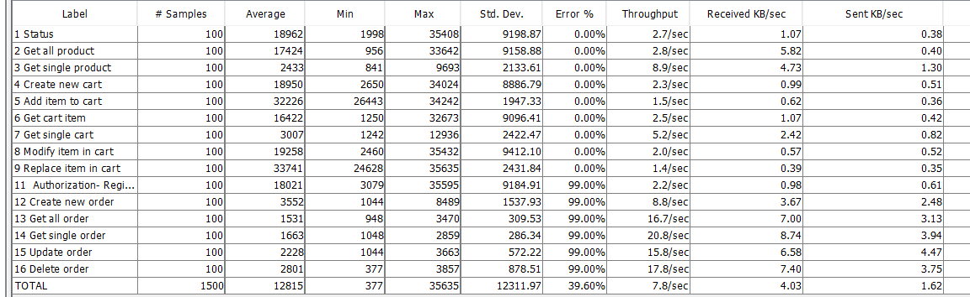

Fig 1.2 Statistics report for 100 users with timer (SS-from index)
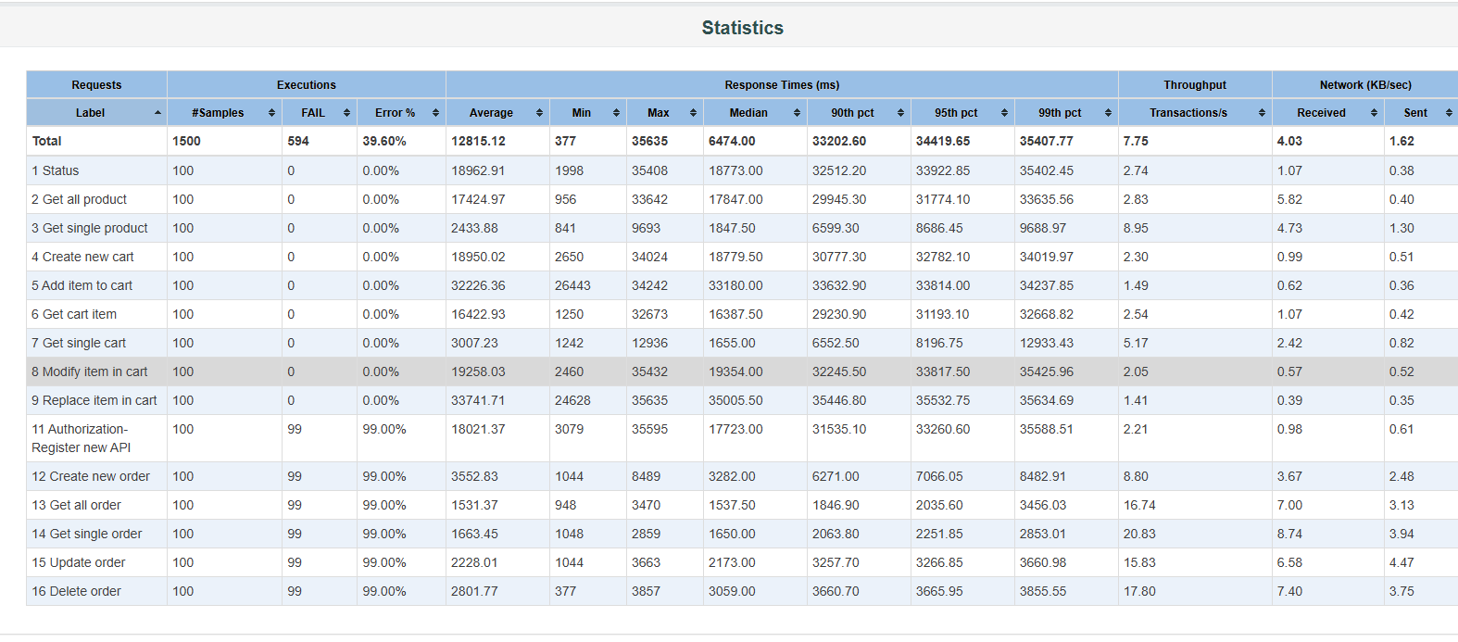

2. Summary report for 200 User
a. 20Sec Ramp-Up Period

Fig 2.1 Summary report for 200 users with timer (SS-from Jmeter)
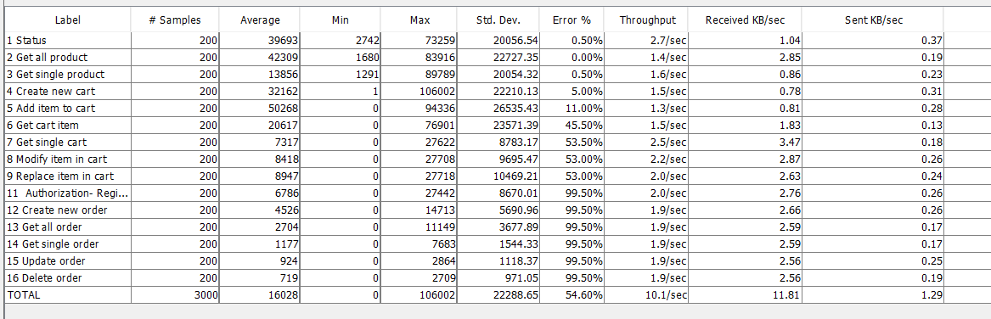

Fig 2.2 Statistics report for 200 users with timer (SS-from index)
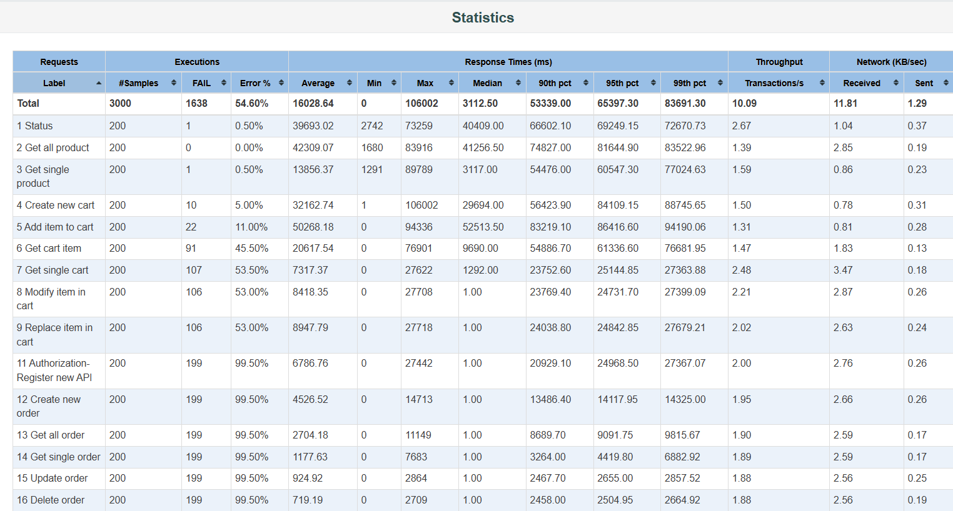

3. Summary report for 400 User
a. 20Sec Ramp-Up Period

Fig 3.1 Summary report for 400 users with timer (SS-from Jmeter)
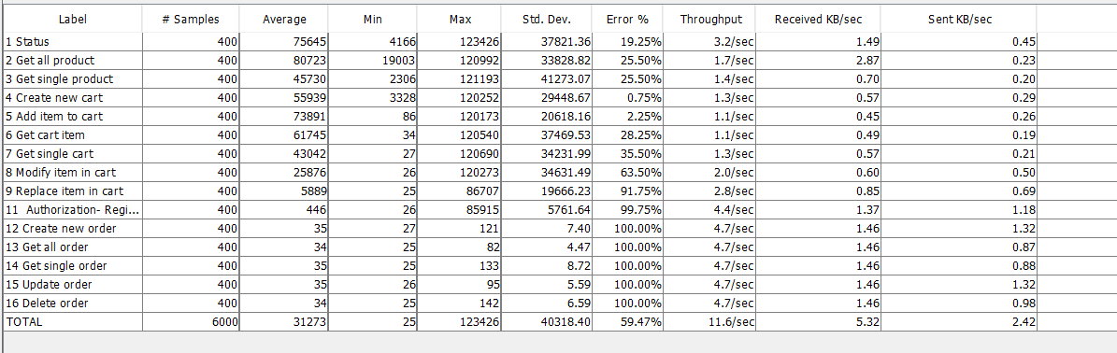

Fig 3.2 Statistics report for 400 users with timer (SS-from index)
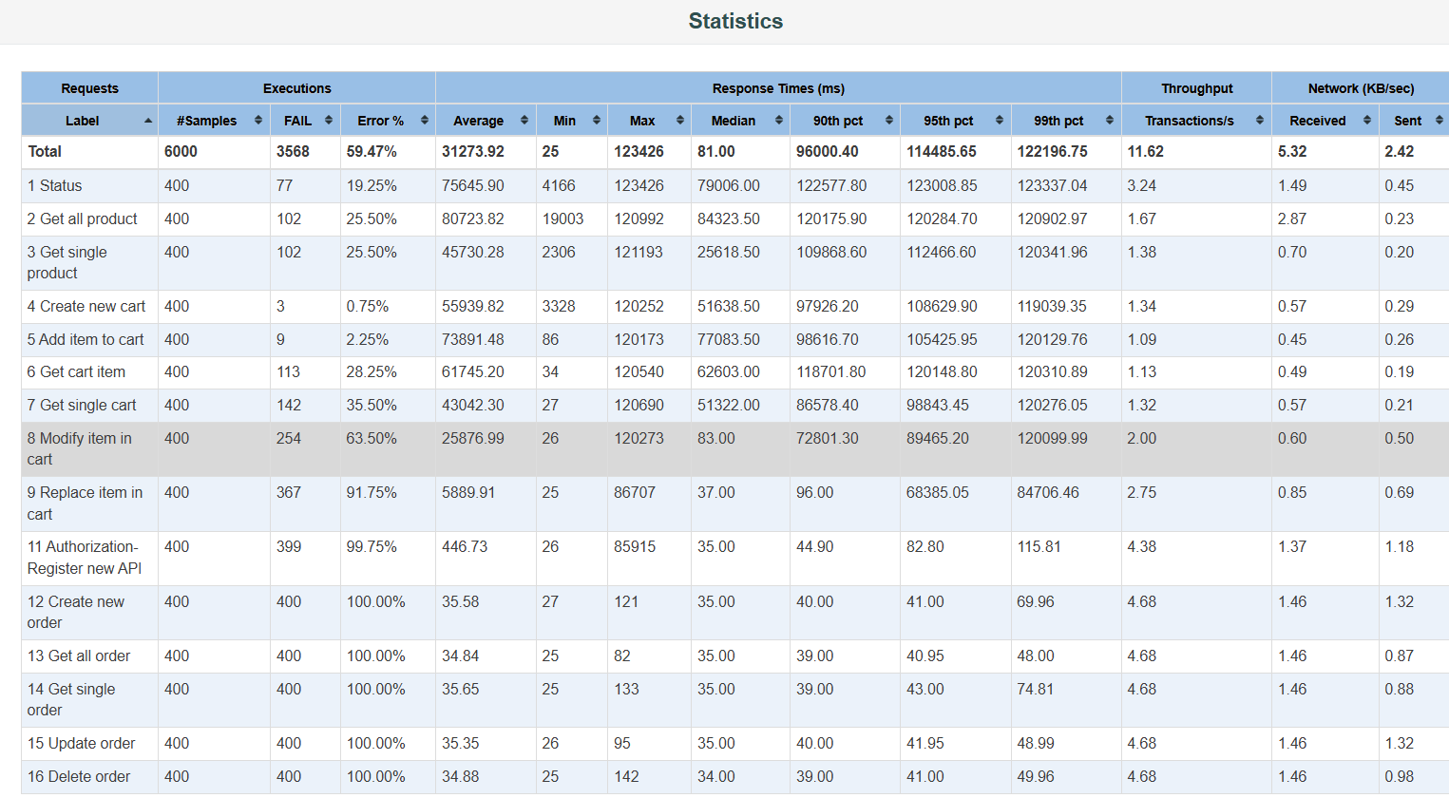

4. Comparative Table for define scenario
Sr.No. | Sampler | 20ms |  | 60ms
 |  | Throughput  (sec) | Error  (%) | Throughput  (sec) | Error  (%)
1 | 100 | 25.4 | 20.04 | 15.36 | 10.02
2 | 200 | 30.36 | 58.05 | 17.39 | 25.36
3 | 400 | 40.23 | 60.56 | 30.58 | 69.01

4.2 Aggregate Report:

The aggregate report is the same as the summary report except the aggregate listener provides some additional parameters such as Median, 90% Line, 95% Line, 99% Line.

• Median: The median is the time in the middle (50%) of a set of results.
• 90% Line: 90% of the samples took NO MORE THAN this time. The 10% remaining samples took at least as long as this.
• 95% Line: 95% of the samples took NO MORE THAN this time. The 5% remaining samples took at least as long as this.
• 99% Line: 99% of the samples took NO MORE THAN this time. The 1% remaining samples took at least as long as this.

Table 4.2.1 Aggregate report for 100 users with timer (SS-from Jmeter)
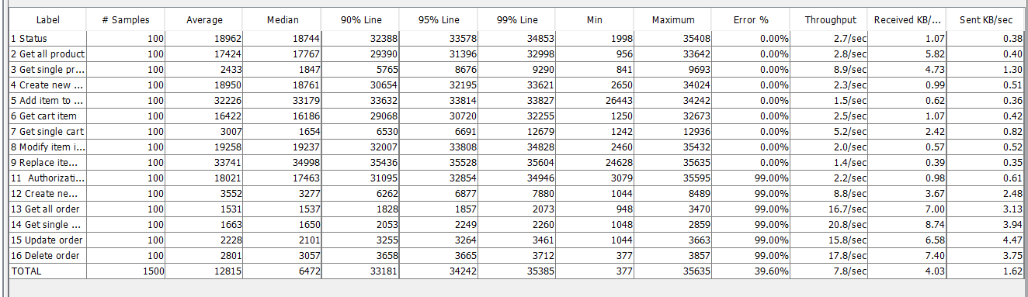

Table 4.2.2 Aggregate report for 200 users with timer (SS-from Jmeter)
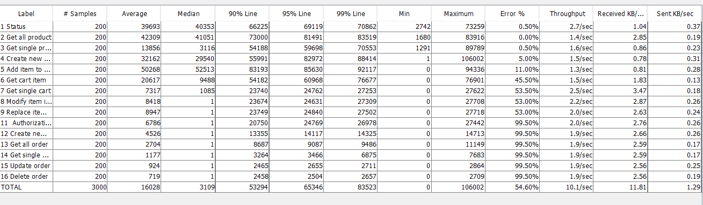

Table 4.2.3 Aggregate report for 400 users with timer (SS-from Jmeter)
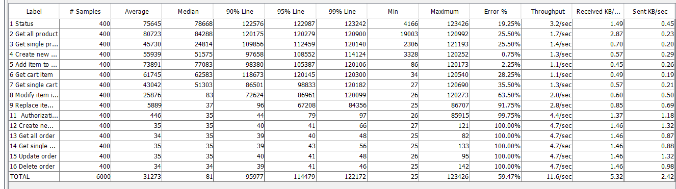

• 4.3 Response Time Graph:

Response time graph gives a clear picture of overall time including requesting a page, processing the data, and getting the response back to the client.
The response time is calculated from the start of the first sample to the end of the last sample. This includes any intervals between samples, as it is supposed to represent the load on the server.
Graph 4.3.1 Response Time Graph for 100 users with Timer (SS-from index)
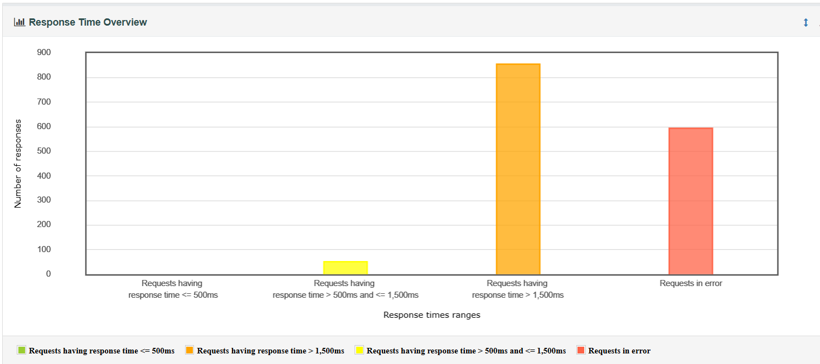
Graph 4.3.1 Response Time Graph for 200 users with Timer (SS-from index)
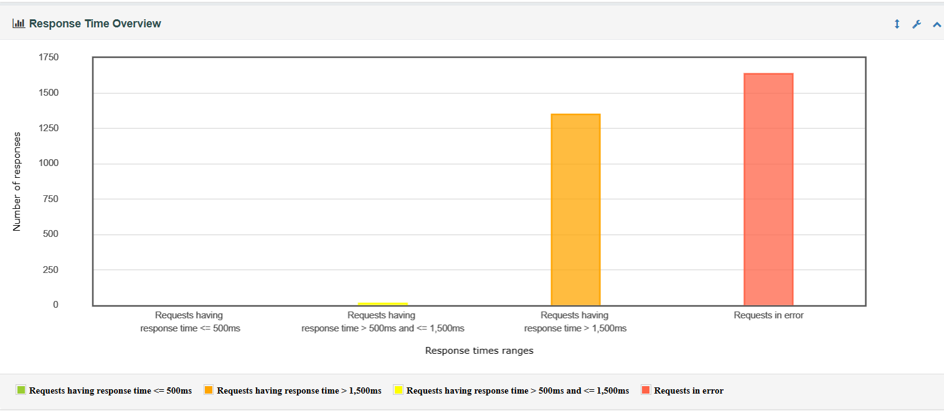
Graph 4.3.1 Response Time Graph for 400 users with Timer (SS-from index)
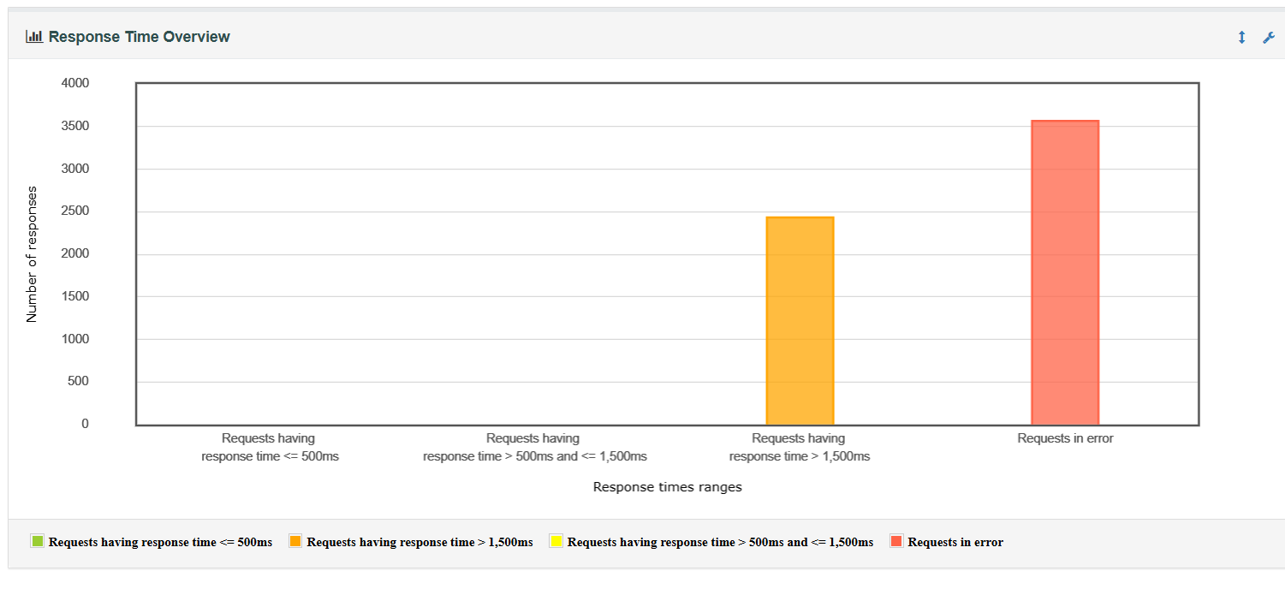

4.4 Errors:

4.4.1 Errors in Percentage

Fig 4.4.1 Error percentage for 100 users with timer (SS-from index)
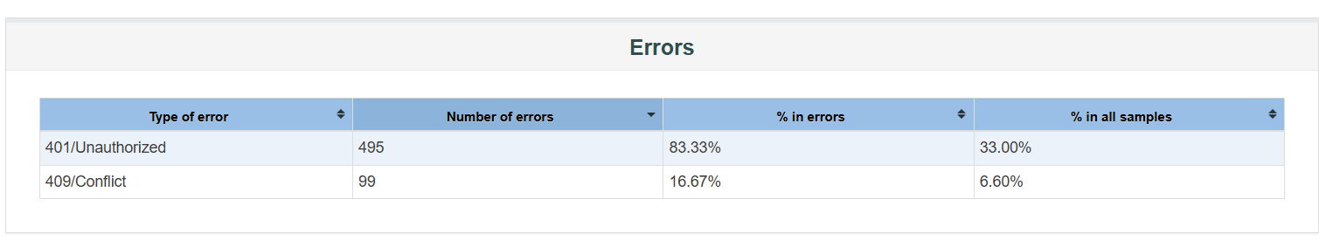
Fig 4.4.2 Top 5 Error for 100 users with timer (SS-from index)
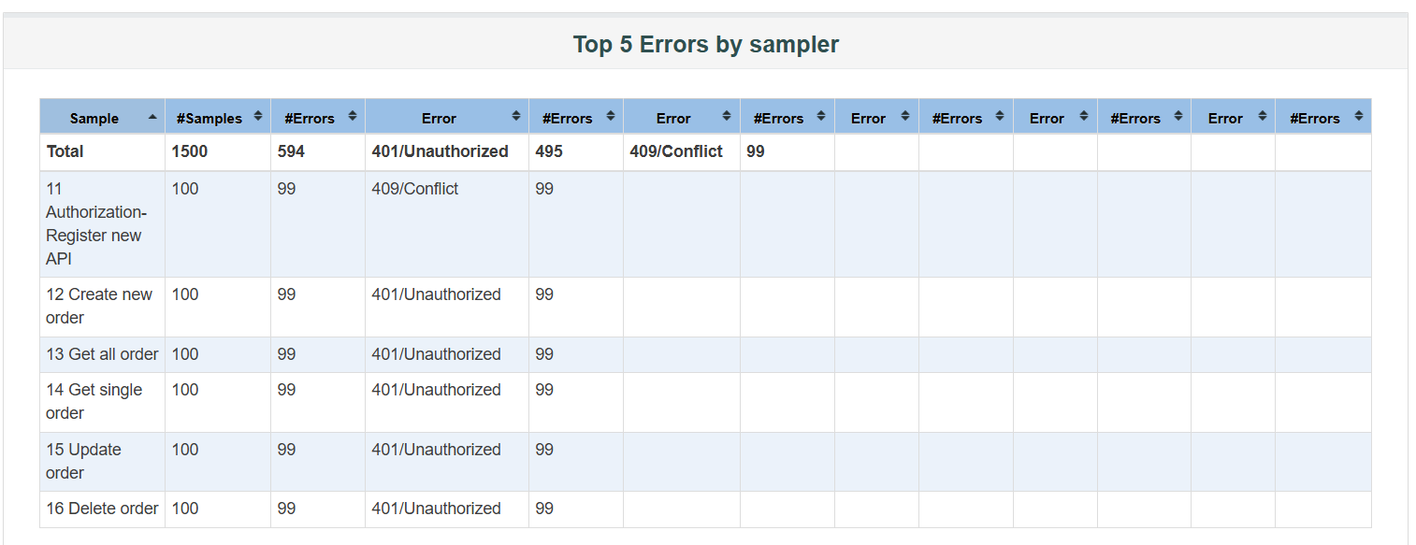

Fig 4.4.3 Error percentage for 200 users with timer (SS-from index)
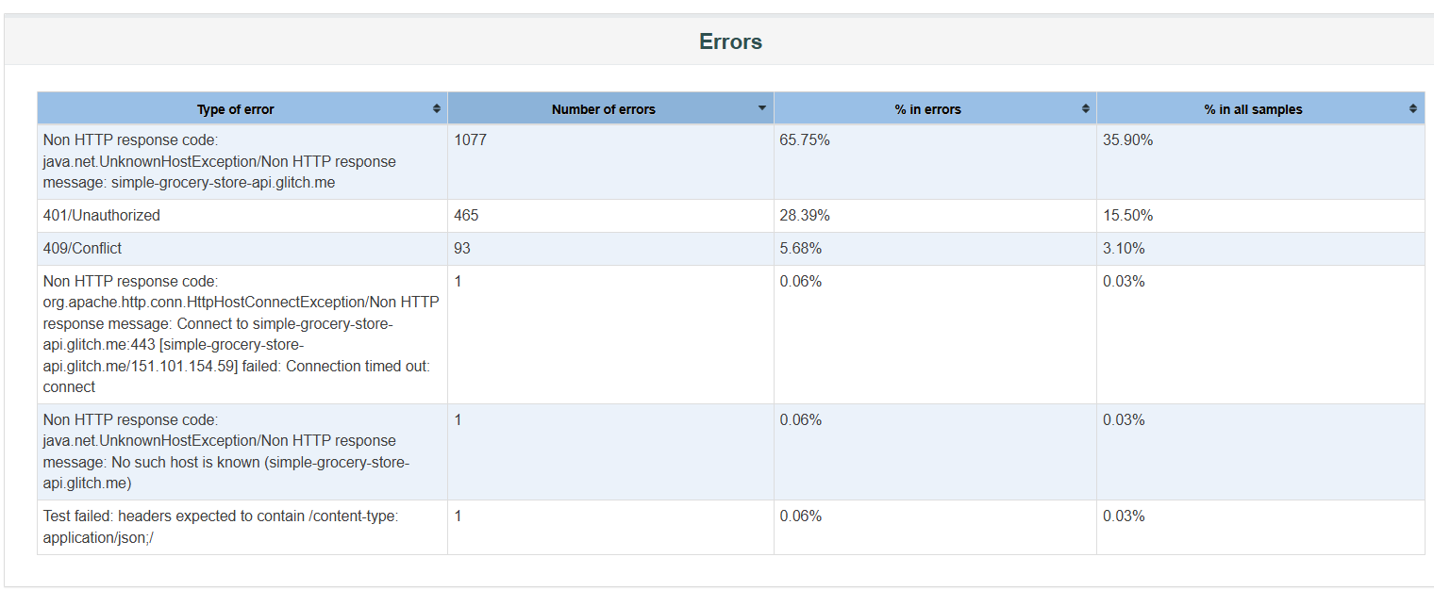

Fig 4.4.4 Top 5 Error for 200 users with timer (SS-from index)
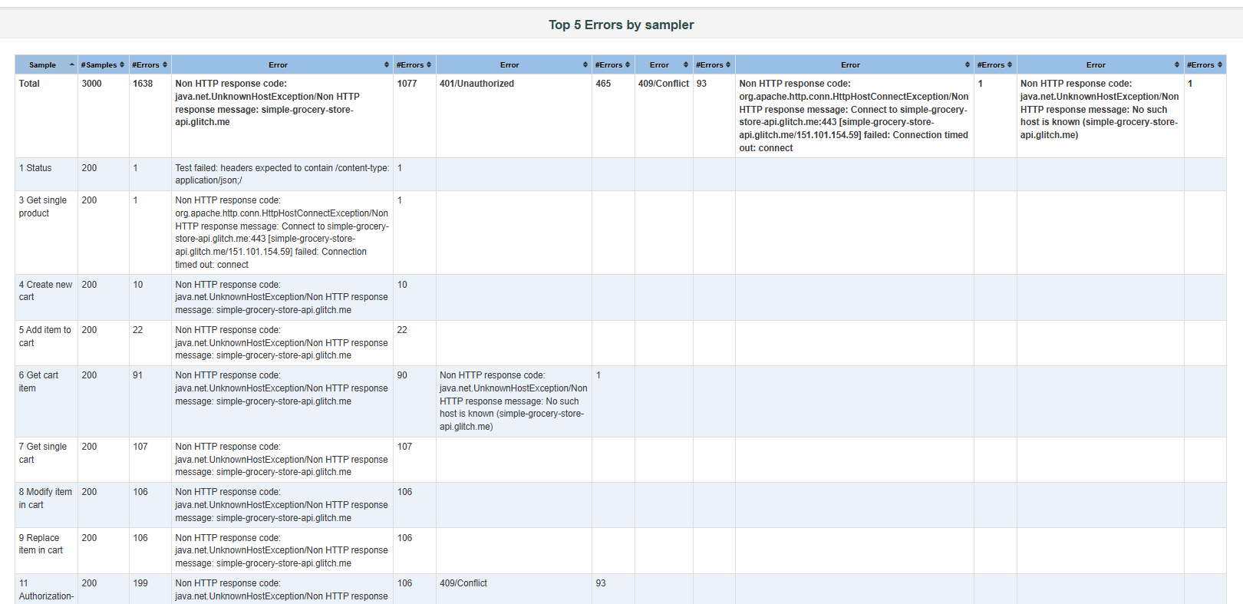

Fig 4.4.5 Error percentage for 400 users with timer (SS-from index)
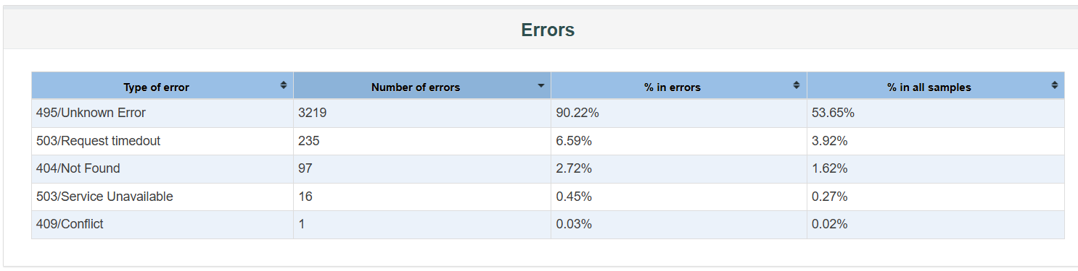

Fig 4.4.6 Top 5 Error for 500 users with timer (SS-from index)
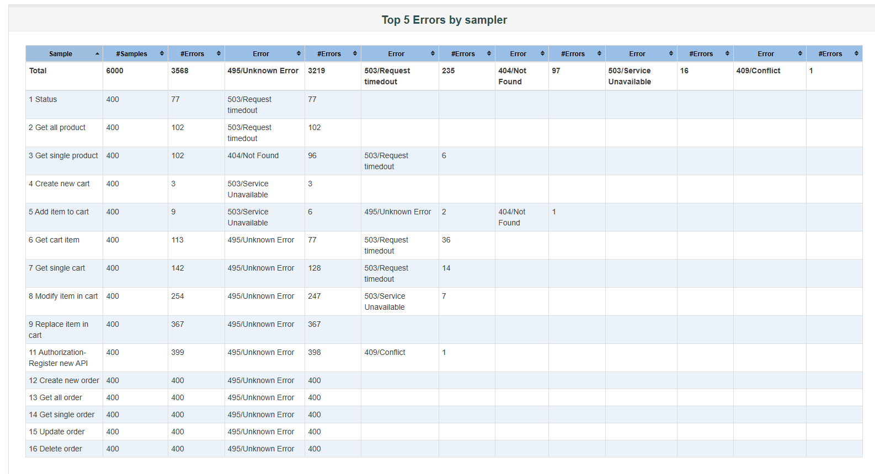

5. Conclusion:
As per defined objective the error percentage is very high and throughput is also not as per the expectations. As the no of user increase the error percentage and response is also increased which need to reduce.
For achieving the desired result following approach can be followed.
1. Server Architecture needs to review.
2. Unwanted request response parameters should be removed.
3. Code needs to be optimize.

